 | 7.0.17 Editors - 3D Viewport - Grease Pencil object - Weight Paint Mode - Brushes context menu
Table of content
Weight Paint Mode - Brushes Context Menu 1
Radius 1
Strength 1
Weight 1
Direction 1

Weight Paint Mode - Brushes Context Menu

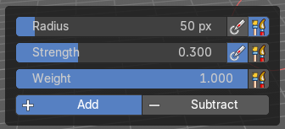
Call this menu with right click in the 3D viewport. You need to be in Weight Paint mode with a grease pencil object. With different tools you will get different context menus, but in the sum the content is basically the same.
In Weight Paint mode you will call a context menu with the sliders from the Brush settings.

Radius
The radius of the sculpt brush.

Strength
The strength of the sculpt brush.

Weight
The vertex weight to paint to.

Direction
Add or subtract the brush stroke.

